Exercise 1 Rory Lange

V1 = 500/500+500+1000 \* 15

V1 = 500/2000 \*15

V1 = ¼ \*15 = 3.75 V

V2 = ¼ \* 15 = 3.75 V

V3 = 1000/ 2000 \* 15

V3 = ½ \* 15 = 7.5V

Exercise 2

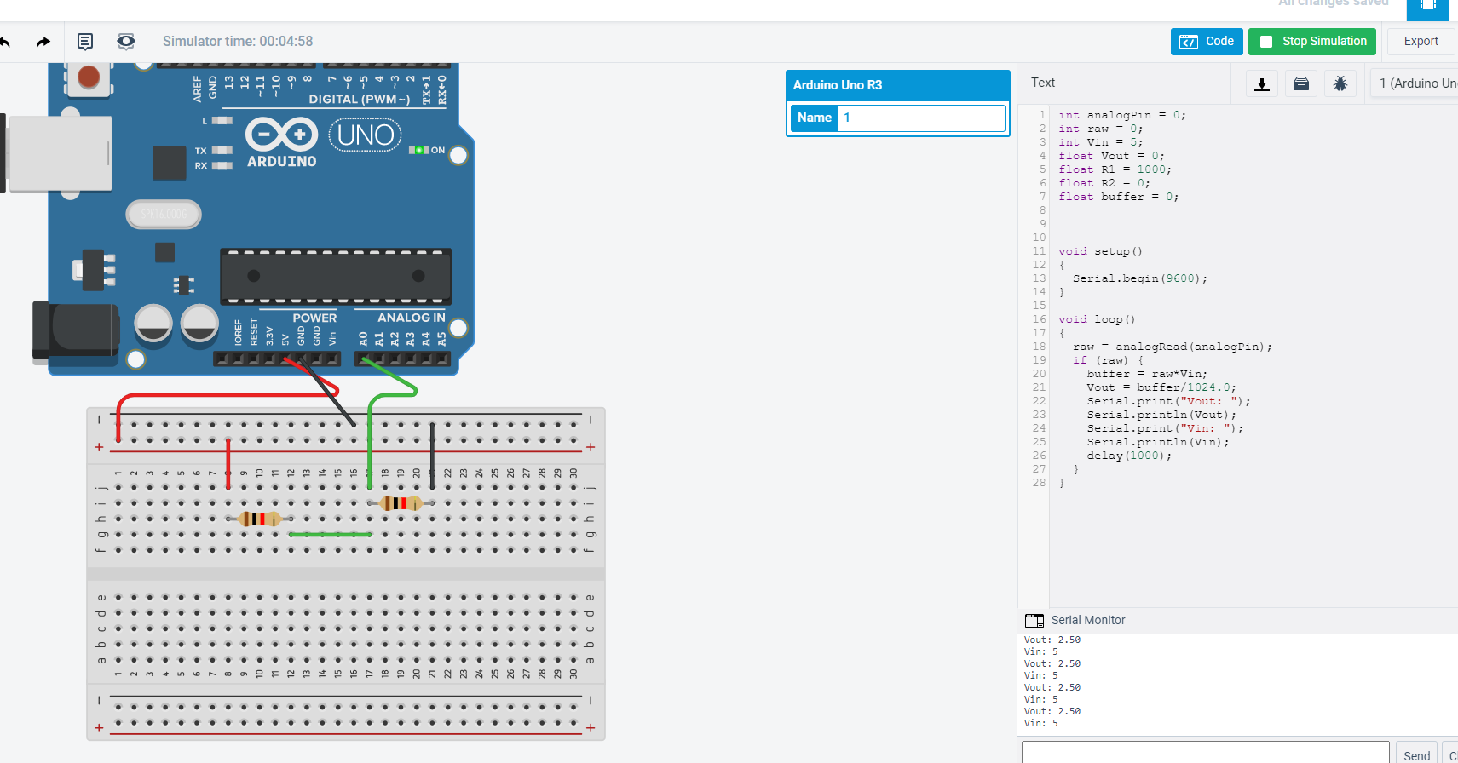

Exercise 3

Req = 1x2x3/1+2+3

Req = 6/5 Ohms

The Req is somewhere inbetween R1 and R2. Ultimately most of the charge will be let through the path with the least amount of resistance

Exercise 4

Req = 1/5 + 1/7 + 1/9

1. Req = 2.20 ohms
2. I = V/R1 + V/R2 + V/R3
   1. I = 8/5 + 8/7 + 8/9
   2. I = 1.6 + 1.143 + 0.889
   3. I = 3.629 Amps
3. 8V
4. R1 = 1.6 amps R2 = 1.143 amps R3 = 0.889 amps

Exercise 5

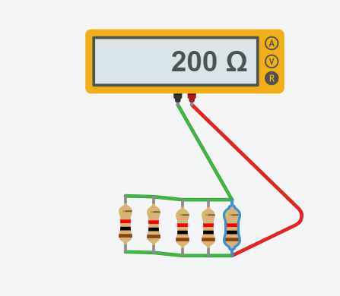

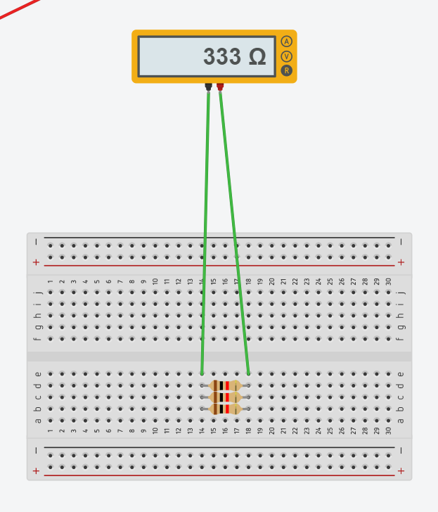

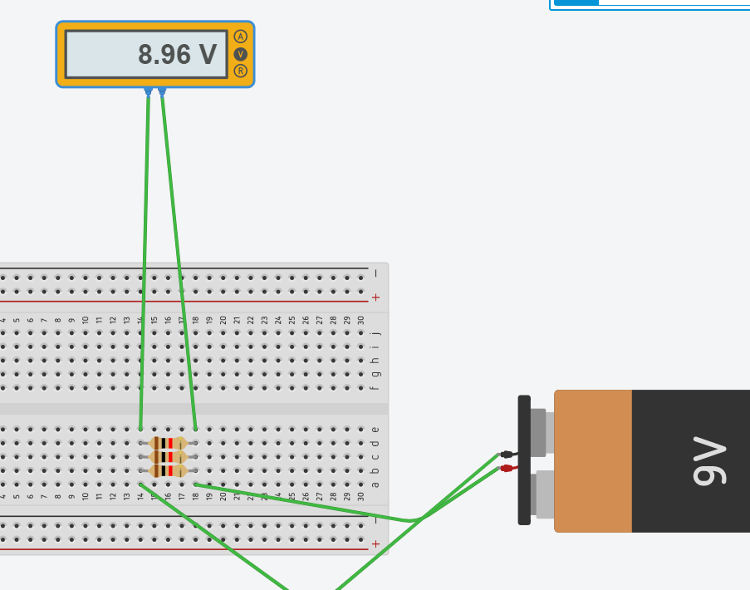

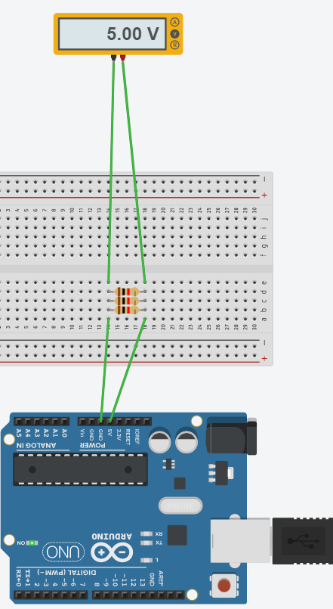

Exercise 6

I1 = 90/30 = 3 Amps

I2 = 40/20 = 2 Amps

I3 = 50/25 = 2 Amps

V1 = 90 Volts

V2 = 20/45 \* 90 = 40 Volts

V3 = 25/45 \* 90 = 50 Volts

Exercise 7

V1 = 24 volts

V2 = 24 Volts

V3 = 15.37 Volts

V4 = 15.37 Volts

Vreq2 = 127.27/198.7 \* 24 = 15.37 volts

Req1 = 1/100 + 1/250 = 250/25000 + 100/25000 = 350/25000 = 71.43 ohms

Req2 = 1/350 + 1/200 = 200/70000 + 350/70000 = 550/700000 = 127.27 ohms

Req = 198.7 ohms

I = 24/198.7 = 0.12 Amps